# PSADT Commands

## Execute-MSI - Installation and Uninstallation

Used to install or uninstall MSI packages.  
  
Syntax:  
**Execute-MSI -Action Install -Path "installer.msi"**

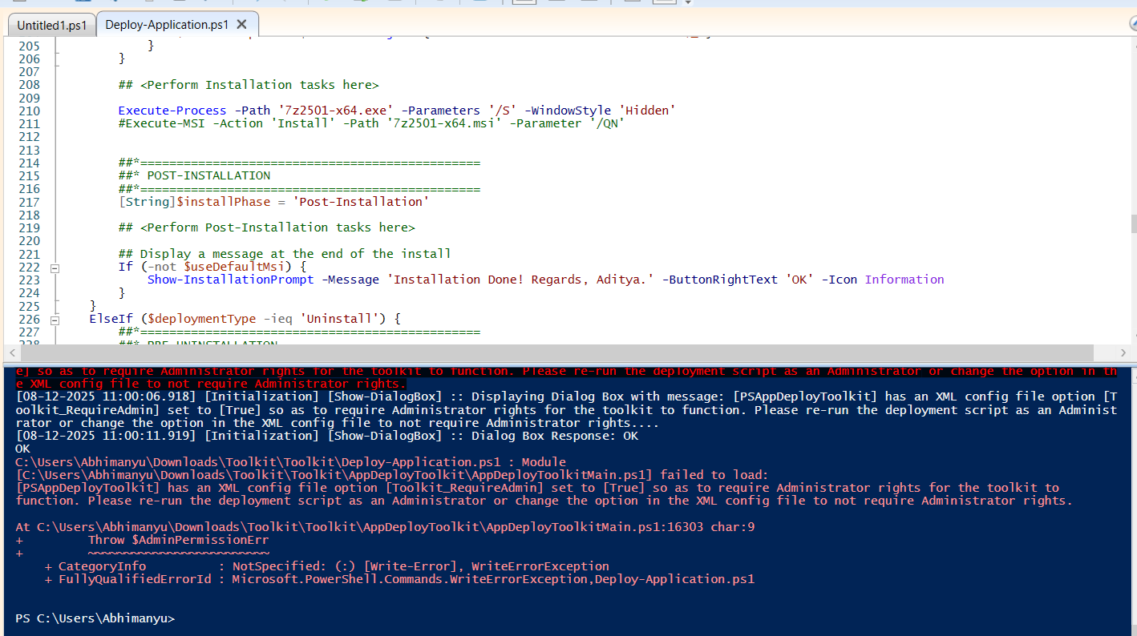

**Execute-MSI -Action Uninstall -Path "installer.msi"**

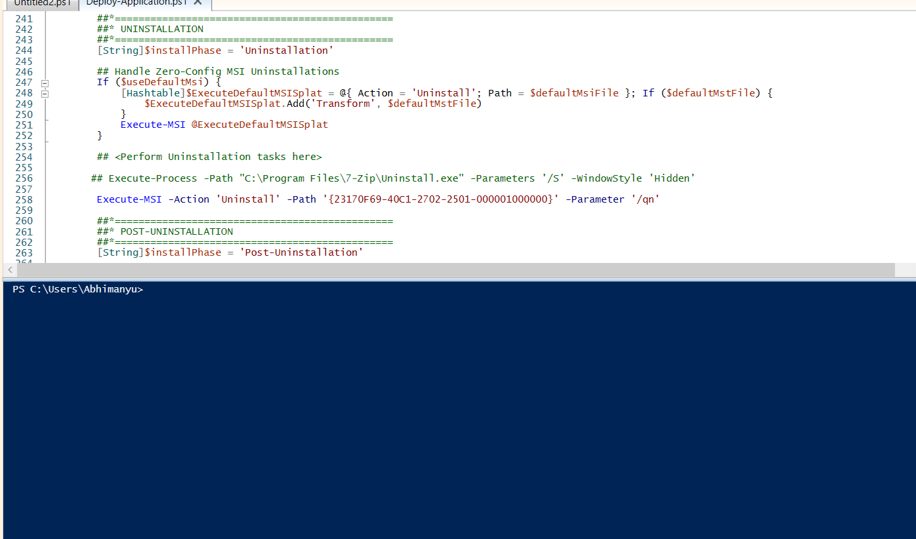  
-Action: Install or Uninstall  
-Path: Name of the MSI file (relative to Files folder or full path)

## Execute-Process

Used to run EXE or other processes.  
  
Syntax:  
**Execute-Process -Path "setup.exe" -Parameters "/quiet /norestart" –Wait**

  
  
-Path: Executable name or path  
-Parameters: Command-line arguments  
-Wait: Wait until process finishes

## Execute-MSP

Used to apply MSP patches to installed MSI applications.  
  
Syntax:  
Execute-MSP -Path "patch.msp" -Parameters "/quiet /norestart"

## Install-MSUPdates

Installs Microsoft Update Standalone Packages (MSU files).  
  
Syntax:  
Install-MSUPdates -MSUFile "update.msu"

## Create Active Setup

Creates an Active Setup registry key to run commands for each user login.  
  
Example:  
Set-RegistryKey -Key "HKLM\SOFTWARE\Microsoft\Active Setup\Installed Components\MyApp" -Name "StubPath" -Value "powershell.exe -ExecutionPolicy Bypass -File C:\Scripts\PerUserConfig.ps1" -Type String

## Copy/Delete/Move File and Folders

**Copy File:  
Copy-File -Path "$dirFiles\myfile.txt" -Destination "C:\Temp"**  
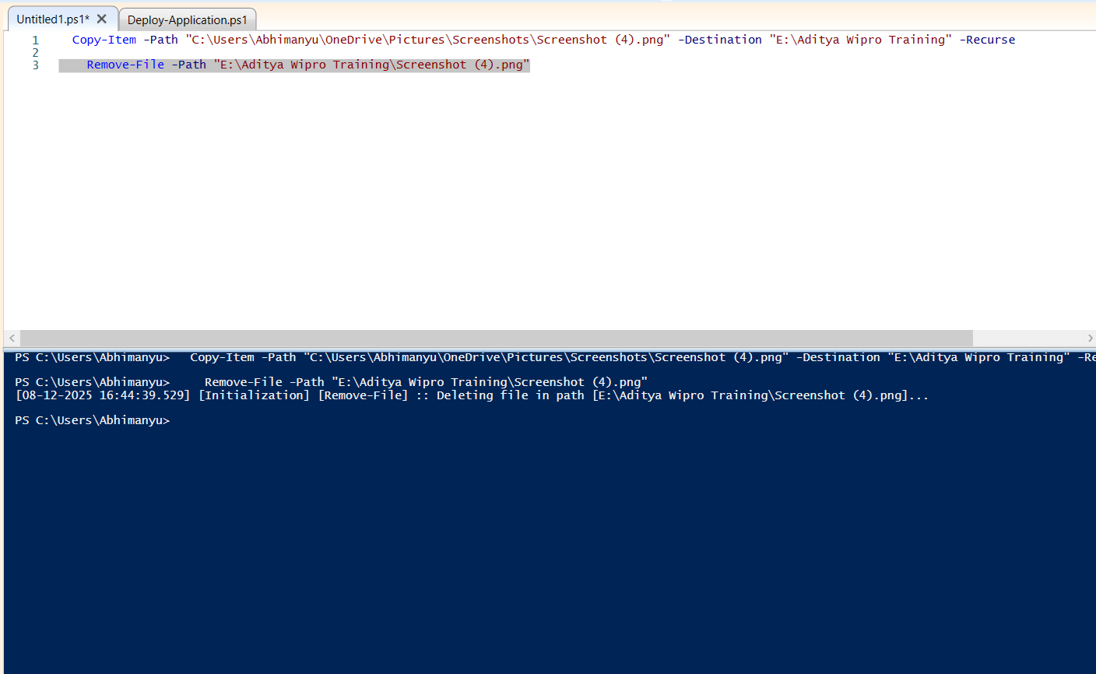  
**Delete File:  
Remove-File -Path "C:\Temp\myfile.txt"**  
  
**Move File:  
Move-File -Path "$dirFiles\myfile.txt" -Destination "C:\NewLocation"**  
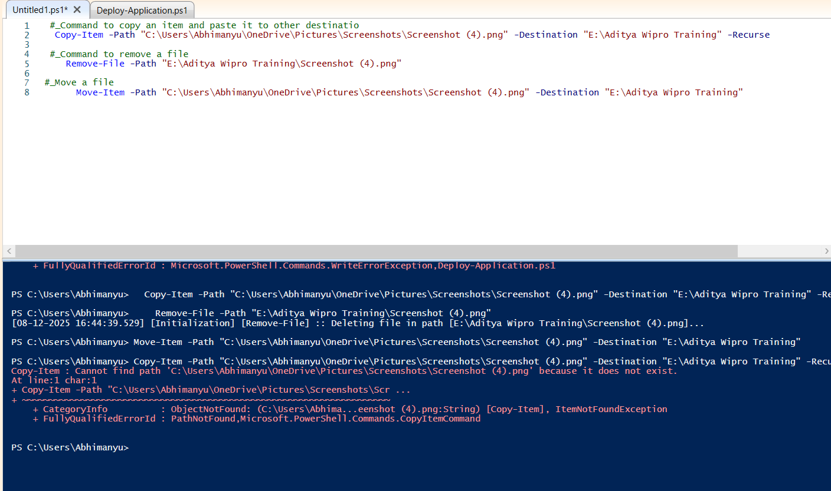

## Commands for Installation/Uninstalation

Installation:  
Execute-MSI -Action Install -Path "app.msi"  
Execute-Process -Path "app.exe" -Parameters "/S"  
  
Uninstallation:  
Execute-MSI -Action Uninstall -Path "app.msi"  
Execute-Process -Path "uninstall.exe" -Parameters "/S"

## Create/Delete/Modify Registries

Create/Modify Registry:  
Set-RegistryKey -Key "HKLM\SOFTWARE\MyApp" -Name "Version" -Value "1.0" -Type String  
  
Delete Registry:  
Remove-RegistryKey -Key "HKCU\SOFTWARE\MyApp"

## Start/Stop Services

Start Service:  
Start-Service -Name "Spooler"  
  
Stop Service:  
Stop-Service -Name "Spooler"